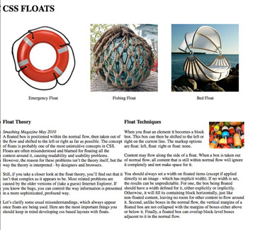

**Create the page structure:**

1. Starting under the <body> tag, create the following tags for the page

2. <section>(surrounds all content inside body)

3. <header> <h1>CSS FLOATS</h1> inside

4. <figure id=one> <figure id=two> <figure id=three>

5. <article id=column-one (surround Float Theory and paragraphs)

6. <article id=column-two (surround Float Techniques and paragraphs)

7. make sure you close with the </section> just before </body>

**Insert Images:**

emergency_float.jpg fishing_float.jpg and bed_float.jpg

8. Put images and captions inside each figure tag as follows

note that we are using a new html 5 tag <figcaption>

9. <figure id=one>><img src="images/emergency_float.jpg" width="250"

height="250"><figcaption>Emergency Float</figcaption></figure>

10. Repeat for the other two figures using fishing and bed images and add a caption for each.

**Now we’ll add the css code to our page:**

11. First set the page width with a <section> width of 1000px

12. Let’s float!!

13. We’ll float the images in a horizontal row.

14. #one { float: left;}

15. Repeat for #two and #three (do they fit? ) must be no wider than our container or you’ll have to redefine container width.

*Note: with css you can duplicate code for elements by including multiple selectors separated by comas: #one, #two , #three {*

How would you target the caption and center under the image?

**Now the columns:**

16. article id=column-one { width: 425px; float: left; }repeat for column-two

The spacing will look a little off; how would you apply margins or padding to fix this?

17. Insert the small image just after the <h3>Float Techniques</h3>

18. <img src=images/little_floats.jpg>

**You can float with a class:**

19. We can float the small picture to the upper right of #column2 with the following

class applied to the image. Create the class .floatright

.floatright { float: right;} then apply to the image tag <img class=floatright src=”*image”>*

Now fine tune the demonstration by adding classes for the banner, captions and

column titles.

20. How would you make the small image move to the top left of the column?

21. If your columns are a little close. How would your adjust?

22. How could you center this page in the browser window?